

**Deployment Guide**

**Ranking Management module - FA Tools**

# 1. Overview

Below, we will guide you on how to set up the environment and run our project on your computer.This project uses **React** for the Frontend, **Spring Boot** for the Backend and **SQL Sever** for the Database.

# 2. Requirements

* **Node.js** (>= 14.x) and **npm** (>= 6.x)
* **Java Development Kit** (JDK 17)
* **Maven** to build the Backend (Maven 3.9.9 - optional).
* **IDE**:
  + Visual Studio Code (Frontend)
  + IntelliJ IDEA or Eclipse (Backend)
* **SQL Sever**

# 3. Frontend Setup

**3.1. Installation and Run**

1. **Clone the project**:
2. git clone <https://github.com/Halocau/FA_Tools_Ranking_Management.git>

cd frontend

1. **Install dependencies**:

npm install

1. **Run the application**:

npm run dev

The application will run at http://localhost:3000.

1. **Build for Production**:

npm run build

# 4. Backend Setup

**4.1. Installation and Run**

1. **Clone the project**:
2. git clone <https://github.com/Halocau/FA_Tools_Ranking_Management.git>

cd backend

1. **Build and run the Backend**:

mvn clean install

mvn spring-boot:run

1. **API Server** will run at http://localhost:8080.

# 5. Environment Variables

Create a .env file for the Frontend:

VITE_API_URL=http://localhost:8080/api

# A screenshot of a computer Description automatically generated6. Project Structure

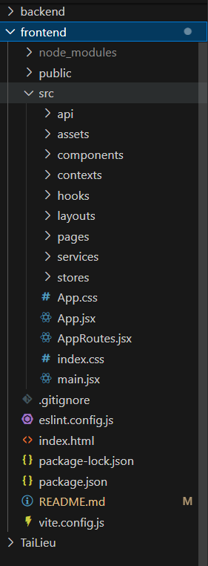

# 8. Run Full Project

1. **Start the Backend** .
2. **Run the Frontend**.

# 9. References

* [Spring Boot Documentation](https://spring.io/projects/spring-boot)
* [React Documentation](https://reactjs.org/)
* [Material UI Documentation](https://mui.com/)
* [Axios Documentation](https://axios-http.com/)
* [JWT Guide](https://jwt.io/)
* [Certbot Guide](https://certbot.eff.org/)